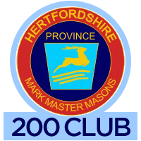
Result of draw 63 – June. 2023
Total collected this month (100%): £715
Prize money (50%): £357.50
Total raised for Provincial Benevolent Fund
this financial year (£1057.50)

 | Numbers | Prize | Winners &  Lodge No.
1st | 006 | £100 | Colin Brett  1505
2nd | 061 | £90 | Lloyde Sargent  1291
3rd | 113 | £77.50 | Keith Emmerson  1291
4th | 103 | £30 | David Newell  241
5th | 92 | £30 | Alex Hurley  872
6th | 23 | £30 | Brian Gerbaldi  909
Draw conducted on Thursday 29th June 2023
at meeting of PGMs LOI at Halsey Hall, Watford
Bag Holder: W Bro Les Woodgate Prov. Grand JD
Number Puller: W Bro David Horne, Prov. Grand Charity Steward
Results recorder: W Bro Dennis Brown, Assistant Charity Steward
Next draw: July, 2023
ke
Grand Total raised since start of scheme, including monies donated back: £17, 697.50
Well done all you Mark Masons

Proforma updated June, 2023

