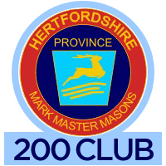
Result of draw 61 – April. 2023
Total collected this month (100%): £700
Prize money (50%): £350
Total raised for Provincial Benevolent Fund
this financial year (£350)

 | Numbers | Prize | Winners &  Lodge No.
1st | 031 | £100 | Ted Long  1489
2nd | 059 | £85 | Valerie Brown  974
3rd | 028 | £75 | Graham Long  354
4th | 054 | £30 | Chris Slater  1358
5th | 137 | £30 | Graham Lovett  556
6th | 135 | £30 | John Letham  1114
Draw conducted on Weds. 28th April, 2023 at Halsey
Hall, Watford at meeting of PGMs LOI
Bag Holder: W Bro David Horne, Prov. Grand Charity Steward
Number Puller: W Bro Richard Harvey, Preceptor PGMs LOI
Results recorder: W Bro Dennis Brown, Prov. Assist. Charity Steward
Next draw: May, 2023
ke
Grand Total raised since start of scheme, including monies donated back: £16, 990
Well done all you Mark Masons

Proforma updated April, 2023

